Investigatation on the key differentiators of 5G technology as compared to the previous 4G and 3G technologies.

**Rup Utpal Paul**

**18BEC1071**

**Abstract**

This proposal will show that the fifth-generation network technology will enhance by using some key differentiator applied to this. It will provide a tremendous amount of high-speed network transmission architecture for long-distance data transmission. There are some key technologies included in this advancement which makes it more reliable. By using this enhancement, the 5G technology is capable of rolling out the IoT. So this on the research, it is said that the fifth-generation network technology with this key differentiators will replace the slow network architecture and provide various solutions for advance technologies where data transmission is essential like IoT.

Contents

Introduction 4

Aims and objectives 6

Initial literature review 7

Ethics relevance and progress 11

Technology and resources 12

HetNet 12

Massive MIMO 13

Auxiliary Spectrum Bands 14

New Core Architectures 14

Research model and work plan 15

Scheduling and processing handling 16

References 18

# Introduction

5G is a new generation technology that comes within the fifth generation of the internet. It is wireless technology. Just as separate connections were required to be made for mobile devices, machines, or all other devices within 4G or 3G generation, now all machines, devices, and other devices can be connected within 5G technology.

The research topic is based on the key differentiators for 5G. So there are various people involved in the development and enhance the capacity of 5G architecture as well as connectivity with IoT. There are various stakeholders involved in this, including the project planner who is responsible for handling and managing the project, architecture design, and development team that is responsible for meeting the requirement with the desired functionality of the 5G network. Agencies and companies that invested money in the project. So there are some other types of people involved as a stakeholder in this. The main concern is focused on the adaptability of the 5G network with other algorithms and technologies that are capable of enhancing the speed and capability of the network, so the result is to modernize the functionality of iot devices that are used in the concept of smart cities. In a way, it can also be known as a high-speed network because the data network inside it is very high. Its capability and performance are very reliable due to its internet speed. Through its connection, many users will be able to use the same thing simultaneously. With the help of this technology, new industries and new services are expanded.

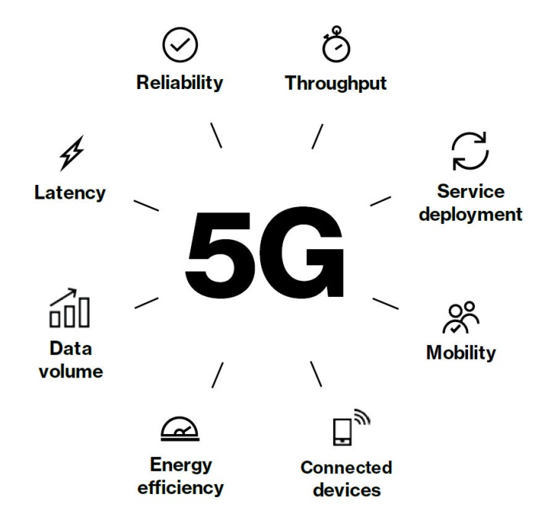

There are some critical issues found in the development of this technology; some of them are related to the network structure, and some relate to operating and cost (Fulton, 2020). Building a complex den network will need a significant amount of complex network architecture because the 5G network antenna uses the RAN hardware that needs more space than the existing 4G network antenna. Maintenance and operational cost need to be low because most of the architecture and hardware use will increase the cost, so it is quite complex to keep operational and maintenance costs low. The 5G network requires ultra-low deterministic latency for functioning properly. The single millisecond delay of one way communication will affect the entire infrastructure so the latency network cannot handle this speed and volume of data. There are also some security risks involved because every new technology comes with new security risks.

The key differences for 5G are mainly defined as the possibilities to improve the 5G network architecture by improving speed and performance. There are some other possibilities, and a new opportunity will open by using this approach, including industrial and robotics, by improving the performance of autonomous operations. This is also measured the effects on the aerospace and defence industries of a country. The stakeholders also found significant benefits investing efforts in this project because the major goal of this is related to improve the 5G network performance. That will affect what the industry that is interrelated with network topology and the internet is.

# Aims and objectives

5G technology has launched inside the market today. Still, some advance changes are inside it. Just as the technology which came within the first generation, their data rate was very high as soon as they started. Therefore, efforts are yet to be made to reduce the data rate of 5G technology. In order to fulfil the pomegranate's standard duties and its functions, some advance is still underway within the 5G technology to increase its user experience by further increasing its speed and deliverability. Reducing the interference to noise fibres that occur when using the connection. Advance to high-quality video calling using the V2V method. The project is focused on the key differentiators used in 5G technology. This will increase network capacity, latency, and bandwidth. So enhancing technology is a smart goal because it will provide the next level advancement in broadband and internet services. Also, various technology that needs higher network allocation like IoT, smart city concept, online streaming, and video chatting are highly in control by using this.

The goal is to complete the achievable because there are not only a specific organization or country, but different countries and different types of organizations at different levels are working on it. Some advanced concepts are already applied in in specific city for testing this functionality. According to some predictions, technology will completely be established in higher growth countries in the next 2 to 5 years. Show the project is capable of achieving the desired functionality and advancement of the 5G network in the given time. The goal of this project is to provide a more efficient routing algorithm and a network architecture that will increase the speed of data transmission. The main advantage that works to achieve this goal is that the technologies that will provide the enhancement in the current technology are already developed. So trying this technology and adapting the new things in that technology is not quite complex. There must be a huge testing process that will be applied, but these all are achievable (Gavras, 2019).

The goal is finite and timely achievable with the current and future technology. This me, the business growth of this technology is higher than the other technologies. Because advancement applied to the 5G technology and the differentiators that make this technology unbeatable are corrected with specific business goals improve in terms of technological growth. In order to fulfil the pomegranate's standard duties and its functions, some advance is still underway within the 5G technology to increase its user experience by further increasing its speed and deliverability and reducing the interference to noise fibres that occur when using the connection. Advance to high-quality video calling using the V2V method.

Also, we can say that the project is timely achievable because all the necessary requirements are found. Also, proper planning and stages are needed to be developed so that the complete project is timely achieve.

# Initial literature review

The topic is related to the 5G technology, and the name of the topic is "The key differentiators for 5G". It also describes advanced technology that enhances the capability of mobile network technology, considered as 5G. The project reports, the key differentiators, which are the concept and functionality that will bring the 5G network technology to the next level. The project proposal includes various types of technology, including HetNet, Massive MIMO, Auxillary spectrum bands, and its core architecture. The project will also discuss the evolution of 5G technology to achieve the goals that are related to IoT. The project will aim for an efficient routing algorithm that will increase the speed, latency, and usability of 5G network architecture by implementing a dynamic routing algorithm. The report will also focus on some core networking fundamental objectives that will increase technological capability. The improved routing architecture will increase the data transmission process in the network. By using these various devices that are based on the IoT will works fine. By increasing the efficiency and potential of the 5G network will also help to grow various other sectors, including robotics, artificial intelligence, self-driving cars, smart homes, and many more. This includes distant communication by using millimetre waves, improve the capacity of using IoT application by using 5G technology. The project will also provide a complete architecture that followed the advancement of 5G technology.

The next-generation wireless technology is highly reliable to handle all type of communications. At the present time, the cellular system uses ultra high-frequency bands and microwave to transfer the data multi-user multi-input and multi-output based on the multipoint, heterogeneous, carrier aggregation network, as per the report provided by the IEEE research regarding MU-MIMO. The wireless network technology will be solved by the multimeter wave spectrum that contains a massive amount of raw bandwidth. Accordimng to Samimi (2016) this is the reason the 5G cellular network uses a channel model that is required to handle sub-6GHz and mmWave spectrum by using this the system-level simulation process are performed with a multi-band system. So the issue that is related with to transfer the data on and long distance will be easily handled by multimeter waves. Because this will provide and advance architecture for 5G network to transfer the data from short distance to long distance. The report also shows that the environmental observation of data loss in a network is also much less than 0.1dB. In most case, then it will architecture usually use multimeter waves because it is appropriate for long-distance communication (Samimi, 2016).

The growth of IoT is based on network speed and quality. The new technology sometimes facing some challenges because a specific type of technology is dependent on other technology (Kritsonis, 2019). 5G technology gives a huge advantage in the usability of IoT devices and the project that use IoT based technologies. There is a brilliant algorithm developed in the 5G technology that it provides helping hands to lift up the next generation IoT devices to communicate the wide range of network including smart cities, self-driving cars, artificial intelligence and robotics. According to a research paper provided by IEEE, a new paradigm is developed by 5G technology that intelligently increases the power of IoT. As state in the atticle (Saxena, 2017) the process is done by big data intelligent and communication channel optimization that will create a high data transmission channel for the devices. The IoT gateways are being rolled out by 5G enabled communication devices because it provides emerging features like mm-wave, massive MIMO and C-RAN. That will provide innumerous connectivity, energy-efficient data transmission speed that will commercially roll out of IoT, and resource pooling. So there is a huge possibility to support message devices that have the iot in able capability by 5G-RAN for development and efficient IoT gateway deployment.

There are various key differentiators for 5G technology is used to enhance the capability. Three of them are HetNet, Massive MIMO and Auxiliary spectrum band. These are the most common advancement that is applied in the development of 5G network because the heterogeneous network architecture and enabling massive multiple input multiple outputs is considered as a promising technique to enhance the capacity of fifth-generation wireless communication. As shown in the a massive MIMO enables HetNet framework that is established on one macro cell base station(MBS), which is connected with analogue beamformer, followed by the digital beamformer. Also, Lin (2017) states that this framework will consist of a femtocell base station connected with the digital beamformer. This concept completely follows the infrastructure of 5th generation wireless technology and enhance its capability tu to sending and receiving the data fastly in the proposed network architecture. Furthermore, an alternate direction method is used in distributed implementation for the obtained CoBF, which is used as multipliers. Finally, a specific robust algorithm is applied to the newly created wireless technology that is proposed by the robust HyCoBF algorithm (Lin, 2017).

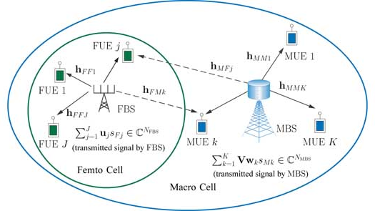

The fifth-generation wireless technology is supported by a new architecture that is designed to increase the bandwidth and latency in the network. Because this technology uses the spectrum band, which is above 24Ghz that is also referred to as multimeter waves. Yazıcı (2014) in the article also shows that the long-distance communication multimeter wave transmission is the only option to travel the data packets from one place to another place. By using the high spectrum allocated size, the oral architecture of the network will increase the capacity and size. As per the research is shown in the IEEE paper, the software-defined network is the newest technology that will enable the network to function tremendous amount of data travelling by using network function visualization opportunity and network programmability. The SDN network architecture works with graphical network control capabilities; this will follow a different grade of performance and complexity provided in the network architecture and services differentiation in the fifth-generation network system. It will also provide a unified approach in mobile ITI and routing management that provides connectivity management as a service differentiation in the architecture of fifth-generation networking technology (Yazıcı, 2014).

# Ethics relevance and progress

Each new technology comes with new power and advancement but here are some risk also comes with the technology. Some ethics issues come with differentiators applied with 5G technology because it will advance the overall functionality of the network. Here is some issue that related to different criteria including human health, privacy, security. These are the ways by which the technological advancement process will effected and sometimes stopped.

* Some health organizations continuously talk about radiation effects on human health. Various organizations will test advancement in the 5G technology and if any concerns will found in the emerging technology. Then the whole project will be stopped because of the human rights organization and agencies, the main ethics issue which is related to the microwave radiation effect on humans and earth.
* Some ethical issues are related to privacy break. We all know that the more devices are connected with the specific technology, the more authentication system needs to be applied. The more authentication means the more ways an attacker can attack and break the security and leak the personal information of specific people or groups of people. This is the most common ethical issue comes while developing or for installing new technology or framework.
* Cybersecurity is the most widely found security issue. It is common in new technology because of the ethic will tell that security is the top priority in any sector or in any technology. The security breaching and attacking specific network technologies and devices are common. In the case of new technology and using this technology will increase the cybersecurity risks (Rawling, 2018).
* The most common attacks are connected with humanity, energy, environment, and e-wastage. That is wholly based on IoT devices. Where the devices are related to the fast network and transmit the data continuously, according to some organizational research, it is found that this type of device and radiation will affect the human brain also the environment and natural processes like wildlife, bees pollination process. The infrastructure also needs high power consumption. So ethical issues are arises.
* Some new human rights laws are being considered. People are affecting the technological environment that will affect the human body. So law and orders are created by various countries that will widely affect the implementation of new technology and IoT. So these are some tissue that comes with the new technology.

# Technology and resources

5G technology has launched inside the market today. Still, some advance changes are still inside it. Just as the technology which came within the first generation, their data rate was very high as soon as they started. Therefore, efforts are yet to be made to reduce the data and advance the 5G technology.

HetNet***:***

Regardless of the difference between a command and an operating system entered by a machine or computer, the connection through which these two are connected is known as a HetNet. It is also used inside wireless technology using different types of technology. In other words, if HetNet is defined, then according to it, controlling it by bringing many connections inside a wireless connection is known as HetNet. It is mostly used within the mobile marketing industry.

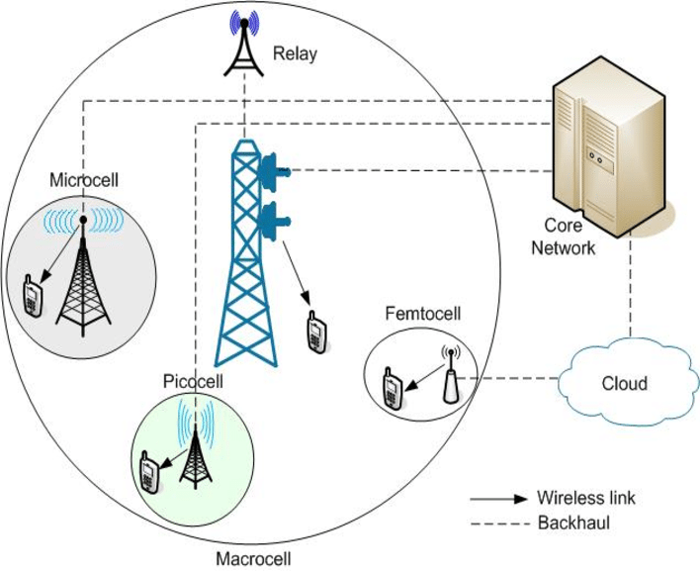

With its help, any command or operation can be regenerated. Radio technology is also used to access it. If a person is using the internet from home, office, or any business or sitting anywhere, with the help of its technology, all of them can be connected.

## Massive MIMO

Massive MIMO is a growing form of MIMO by which the spectrum between the user of the message or data, and the sender of the data is extended, and the service is provided well. Using that method, the capacitance of the antenna is increased. The extra antenna is used inside the Massive MiMo by which more improvement can be done inside the small area as well as to increase its activity.

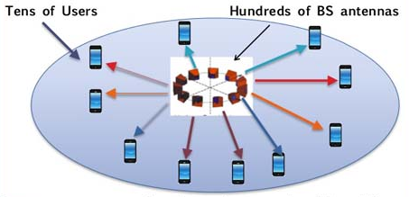

Data speed can be increased up to 300mbps using Massive MiMo.The extra antenna used in Massive MiMo, which increases the speed and reliability of the internet, due to which the capacity of mobile, computer, etc. are also increased, and their performance improves, and their life span also increases.

Auxiliary Spectrum Bands***:***

5G frequency bands are required to use 5G technology. Some primary technology is used inside it like MW bands, massive MIMO, etc. Within the MW band, the ability of the band is provided to the user according to the preference of the user. The speed and capacity of the spectrum band of 5G technology are ten times more than the 4G band. The 5G technology spectrum band should have a capacity of more than 24 GHz.Small frequency spectrum bands are used within live coverage and mobile. High-frequency spectrum bands are used to transmit data over long distances. Spectrum bands of mid-range frequencies are used for use in small towns and computers (Ancans, 2016).

New Core Architectures***:***

The core network architecture will provide a tremendous amount of bandwidth in the network with the flexibility in all different 5G use cases. This architecture will drive the 5G network that includes all the different hardware and technology that are discussed above can drive high-speed mobile and wireless broadband services.

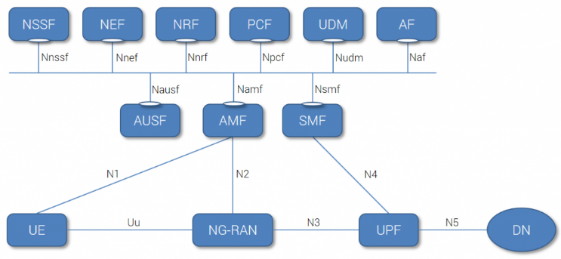

Three things are considered in the advancement of the 5G core network. The user plan function will handle the packet processing and aggregation of traffic that are for the distribution in the network age. Access mobility and management function are capable of handling mobility management tasks that are you how to handle session management in the network. Finally, session management function includes creating updating and removing protocol data unit sessions and managing session contact within the UPF.

The data analysis process is applied to the old collected data and the newly collected data from the process of the 5G network. By using this data, the improved latency is found, and then the architecture is connected with the IoT devices. This initial process in IoT devices is told that the newly created core design of the 5G is capable of handling this.

# Research model and work plan

The basic research model in wireless development technology is categorized into three major phases and one miner phase. The first major face includes smartphone and mobile devices transmission technology improvement. This phase will handle all the interrelated communication technology that is used to enhance the connectivity between mobile devices. The enhanced mobile broadband technology is provided and developed in network architecture for efficient communication. The second phase is focused on autonomous driving devices date uses the high-speed network transmission for communication. The targeted devices are automotive devices that need ultra-reliable low latency communication which is implemented in the second phase. The third phase is considered on massive IoT devices and future technology that needs high-speed data transmission media. Show a different network architecture are developed in this section for massive machine-type communication. Finally, in the minor section, various other types of infrastructure module are created for a different type of services including cloud node, access node, networking and many more. There should be some timeline and time boundation is needed to complete the specific phase because there is various type of technology involved in the fifth-generation wireless technology. There is a significant amount of time needed for development. As described above, various other countries are already working on this the technology will serve the people within the next 2 to 3 years. So the network architecture is capable of handling all the services according to their useability. This research method is appropriate and feasible to provide an end to end solution for a different type of services (French, 2016).

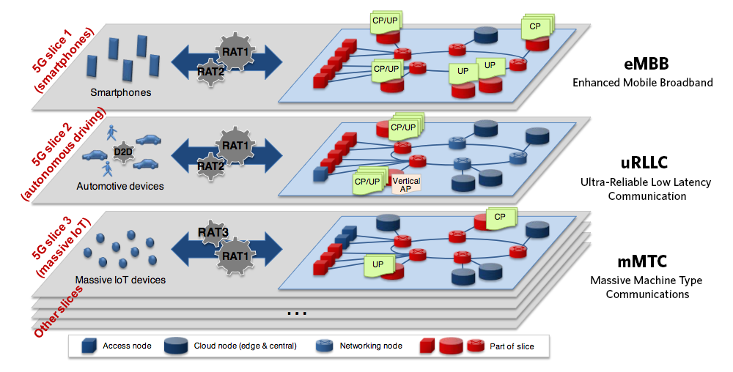

Scheduling and processing handling

The project will fulfil all the necessary requirement to develop the fifth-generation network technology. Also, the enhancement applied in this technology that will provide a solution based on key differentiators. The scheduling and process managing in the network architecture is the combination of various steps. The developing process will handle by the separate department according to the knowledge and skill. An advisory board is assigned to the task that can control and monitor all the necessary process from development to the implementation phase. The project officer is also assigned that is connected with the steering committee and project coordinator. These two are further connected with the general assembly. These all are responsible for handling the initial assembly election process of network architecture and applying the various testing methodology, including both unit and integration testing of a specific section. In the middle of the project development, the technical management team is to work and perform various type of technical tasks like data management, communication management, invocation management and many more.

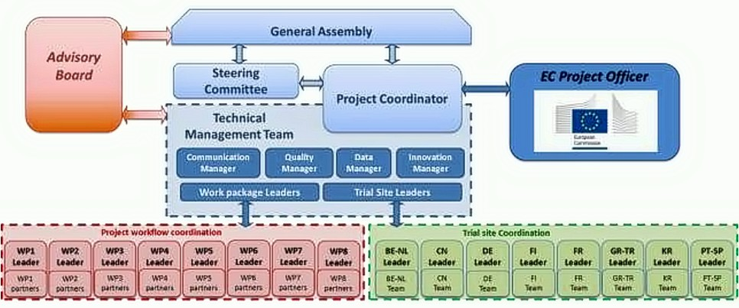

The team is also connected with the project workflow coordination and trials site coordination. These two sections also contain some subprocesses and subtask that are required to build complete network infrastructure. The testing of 5th generation network is critical and potential. There are some complex use cases created by the technical team to find out all the related issues. The advanced simulation and verification technology are applied in the 5G testing that is scheduled 5G development in the field. Both fronthaul and backhaul demands need to be fulfilled by the testing team that is connected with speed, the bandwidth, reliability of the network, synchronization on the network function virtualization. The key differentiator that will improve the 5G network is also tested by the testing team, including new radio, millimetre waves, massive MIMO, beamforming and network slicing. What is the type of testing methodology is applied to check the network framework will work individually and combinedly.

# MIMO

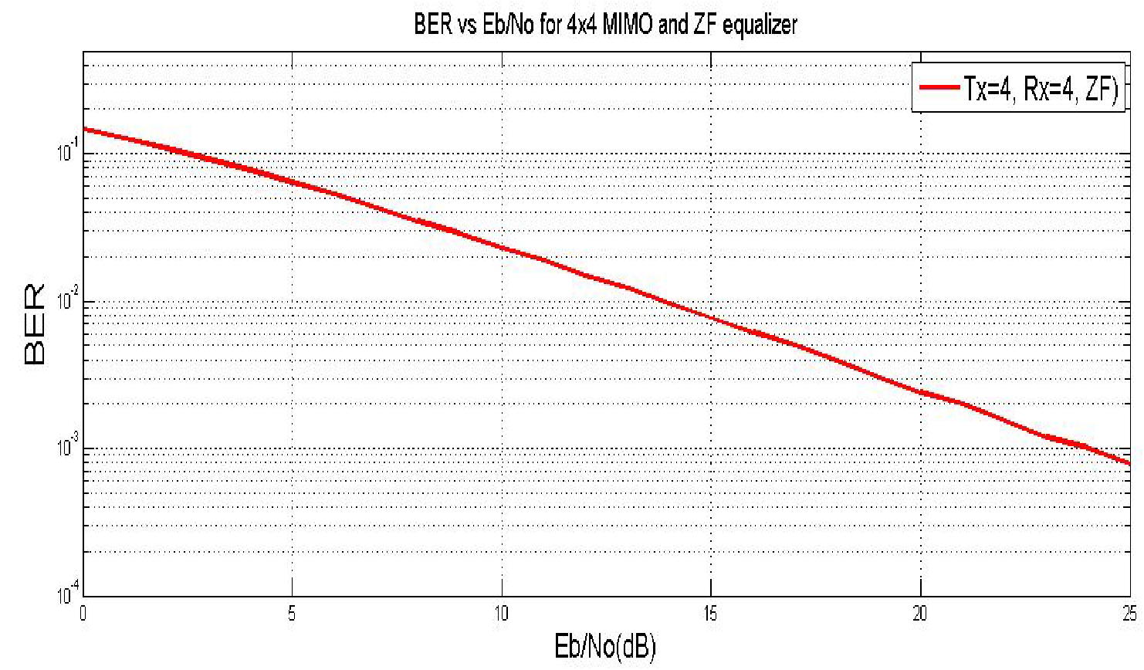O

Figure 1: BER vs. Eb/No for 4x4 MIMO using MMSE equaliser

# Results

In a 4x4 MIMO system, outcome for BER vs. SNR on application of zero forcing equalisation is given in Figure 1. Assessment of findings indicate that for low SNR values BER is not acceptable but for high SNR values BER is modest and may be used for practical design purposes. (Balanis, 1997)

# Code

clc;

close all;

EbN0dB=-4:1:24;

EbN0lin=10.^(EbN0dB/10);

colors={'k-*','g-o','r-h','c-s','m-s','y-*','k-p','b:s','m:d','g:p'};

index=1;

%BPSK

BPSK = 0.5*erfc(sqrt(EbN0lin));

plotHandle=plot(EbN0dB,log10(BPSK),char(colors(index)));

set(plotHandle,'LineWidth',1.5);

hold on;

index=index+1;

%M-PSK

m=2:1:5;

M=2.^m;

for i=M,

k=log2(i);

berErr = 1/k*erfc(sqrt(EbN0lin*k)*sin(pi/i));

plotHandle=plot(EbN0dB,log10(berErr),char(colors(index)));

set(plotHandle,'LineWidth',1.5);

index=index+1;

end

%Binary DPSK

Pb = 0.5*exp(-EbN0lin);

plotHandle = plot(EbN0dB,log10(Pb),char(colors(index)));

set(plotHandle,'LineWidth',1.5);

index=index+1;

%Differential QPSK

a=sqrt(2*EbN0lin*(1-sqrt(1/2)));

b=sqrt(2*EbN0lin*(1+sqrt(1/2)));

Pb = marcumq(a,b)-1/2.*besseli(0,a.*b).*exp(-1/2*(a.^2+b.^2));

plotHandle = plot(EbN0dB,log10(Pb),char(colors(index)));

set(plotHandle,'LineWidth',1.5);

index=index+1;

%M-QAM

m=2:2:6;

M=2.^m;

for i=M,

k=log2(i);

berErr = 2/k*(1-1/sqrt(i))*erfc(sqrt(3*EbN0lin*k/(2*(i-1))));

plotHandle=plot(EbN0dB,log10(berErr),char(colors(index)));

set(plotHandle,'LineWidth',1.5);

index=index+1;

end

legend('BPSK','QPSK','8-PSK','16-PSK','32-PSK','D-BPSK','D-QPSK','4-QAM','16-QAM','64-QAM');

axis([-4 24 -8 0]);

set(gca,'XTick',-4:1:24);

ylabel('Probability of BER Error - log10(Pb)');

xlabel('Eb/N0 (dB)');

title('Probability of BER Error log10(Pb) Vs Eb/N0');

grid on;

# Auxillary Spectrum Bands

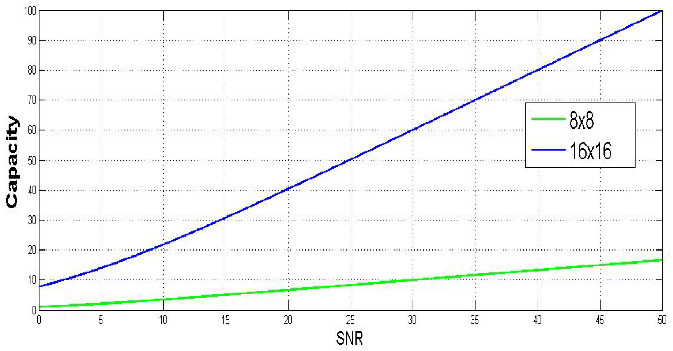

Figure 2: SINR vs. SNR for 16x16 BF, ZFE and MMSE equaliser

# Result

Originally for 3 to 15 dB, the amount of SINR is approximately similar for the intended detection schema. Study indicates that MMSE detects lower interference in the environment than other proposed systems. “*SINR increases with the increase of SNR*”. (Vescovo, 2000)

# Code

clc

clear

format long

N=100000;

SNRDB=6:2:16;

I_da=sign(rand(1,N)-0.5);

Q_da=sign(rand(1,N)-0.5);

s=I_da+1i*Q_da;

for i=1:length(SNRDB)

SNRLIN=10^(SNRDB(i)/10);

n=1/sqrt(2*10^(SNRDB(i)/10))*(randn(1,N)+1i*randn(1,N));

h=1/sqrt(2)*(randn(1,N)+1i*randn(1,N));

y=h.*s+n;

for j=1:3

if j==1

W(1,:) = ones(size(h));

elseif j==2

W(2,:)= 1./h;

elseif j==3

W(3,:)= conj(h)./((abs(h)).^2+n);

else

error('Unimplemented Equalizer');

end

z = W .* y;

z_=sign(real(z))+1i*sign(imag(z));

end

BER_no(i)=sum(s~=z_(1,:))/N;

BER_ZF(i)=sum(s~=z_(2,:))/N;

BER_MMSE(i)=sum(s~=z_(3,:))/N;

end

ax = [6 16 1e-04 8e-01];

axis(ax)

semilogy( SNRDB, BER_no, '*-k', SNRDB,BER_ZF, 'o--r',SNRDB, BER_MMSE, '>-b');

xlabel('E_b/N_0 [dB]');

ylabel('BER');

title('Equalizer for OFDM system');

legend('No Equalizer','ZF Equalizer','MMSE Equalizer');

grid on;

# Latency and packet delay (Multiple MIMO and Beamwidth Diversity)

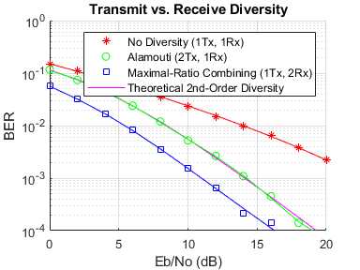

Figure 3: Eb/No(Db)

# Result:

The subsequent simulation findings demonstrate that the use of two transmit antennas and one receiving device produces the same order of diversity as one transmiter antenna and two receiver antennas' full ratio combined (MRC) system. Thus, when implemented using an MRC, the 5G device has a greater diversity of transmission compared to 4G. (Panduro, 2005)

# Code:

% Set up a figure for visualizing BER results

fig = figure;

grid on;

ax = fig.CurrentAxes;

hold(ax,'on');

ax.YScale = 'log';

xlim(ax,[EbNo(1), EbNo(end)]);

ylim(ax,[1e-4 1]);

xlabel(ax,'Eb/No (dB)');

ylabel(ax,'BER');

fig.NumberTitle = 'off';

fig.Renderer = 'zbuffer';

fig.Name = 'Transmit vs. Receive Diversity';

title(ax,'Transmit vs. Receive Diversity');

set(fig, 'DefaultLegendAutoUpdate', 'off');

fig.Position = figposition([15 50 25 30]);

% Loop over several EbNo points

for idx = 1:length(EbNo)

reset(errorCalc1);

reset(errorCalc2);

reset(errorCalc3);

% Set the EbNo property of the AWGNChannel System objects

awgn1Rx.EbNo = EbNo(idx);

awgn2Rx.EbNo = EbNo(idx);

% Loop over the number of packets

for packetIdx = 1:numPackets

% Generate data vector per frame

data = randi([0 P-1], frmLen, 1);

% Modulate data

modData = bpskMod(data);

% Alamouti Space-Time Block Encoder

encData = ostbcEnc(modData);

% Create the Rayleigh distributed channel response matrix

% for two transmit and two receive antennas

H(1:N:end, :, :) = (randn(frmLen/2, N, M) + ...

1i*randn(frmLen/2, N, M))/sqrt(2);

% assume held constant for 2 symbol periods

H(2:N:end, :, :) = H(1:N:end, :, :);

% Extract part of H to represent the 1x1, 2x1 and 1x2 channels

H11 = H(:,1,1);

H21 = H(:,:,1)/sqrt(2);

H12 = squeeze(H(:,1,:));

% Pass through the channels

chanOut11 = H11 .* modData;

chanOut21 = sum(H21.* encData, 2);

chanOut12 = H12 .* repmat(modData, 1, 2);

% Add AWGN

rxSig11 = awgn1Rx(chanOut11);

rxSig21 = awgn1Rx(chanOut21);

rxSig12 = awgn2Rx(chanOut12);

% Alamouti Space-Time Block Combiner

decData = ostbcComb(rxSig21, H21);

% ML Detector (minimum Euclidean distance)

demod11 = bpskDemod(rxSig11.*conj(H11));

demod21 = bpskDemod(decData);

demod12 = bpskDemod(sum(rxSig12.*conj(H12), 2));

% Calculate and update BER for current EbNo value

% for uncoded 1x1 system

ber_noDiver(:,idx) = errorCalc1(data, demod11);

% for Alamouti coded 2x1 system

ber_Alamouti(:,idx) = errorCalc2(data, demod21);

% for Maximal-ratio combined 1x2 system

ber_MaxRatio(:,idx) = errorCalc3(data, demod12);

end % end of FOR loop for numPackets

% Calculate theoretical second-order diversity BER for current EbNo

ber_thy2(idx) = berfading(EbNo(idx), 'psk', 2, 2);

% Plot results

semilogy(ax,EbNo(1:idx), ber_noDiver(1,1:idx), 'r*', ...

EbNo(1:idx), ber_Alamouti(1,1:idx), 'go', ...

EbNo(1:idx), ber_MaxRatio(1,1:idx), 'bs', ...

EbNo(1:idx), ber_thy2(1:idx), 'm');

legend(ax,'No Diversity (1Tx, 1Rx)', 'Alamouti (2Tx, 1Rx)',...

'Maximal-Ratio Combining (1Tx, 2Rx)', ...

'Theoretical 2nd-Order Diversity');

drawnow;

end % end of for loop for EbNo

% Perform curve fitting and replot the results

fitBER11 = berfit(EbNo, ber_noDiver(1,:));

fitBER21 = berfit(EbNo, ber_Alamouti(1,:));

fitBER12 = berfit(EbNo, ber_MaxRatio(1,:));

semilogy(ax,EbNo, fitBER11, 'r', EbNo, fitBER21, 'g', EbNo, fitBER12, 'b');

hold(ax,'off');

% Restore default stream

rng(s);

# Hybrid Beamwidth Formation

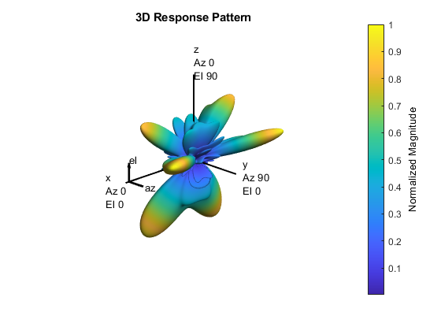

Figure 4: Hybrid Beamforming in 5G

# Result:

The pattern of the array response indicates different data streams defined by the stronger lobes. The distribution or separability obtained by beamforming are indicated by these lobes. (Goswami, 2013)

# Code

% Calculate the hybrid weights on the transmit side

if prm.numUsers==1

% Single-user OMP

% Spread rays in [az;el]=[-180:180;-90:90] 3D space, equal spacing

% txang = [-180:360/prm.nRays:180; -90:180/prm.nRays:90];

txang = [rand(1,prm.nRays)*360-180;rand(1,prm.nRays)*180-90]; % random

At = steervec(prm.posTxElem,txang);

AtExp = complex(zeros(prm.numCarriers,size(At,1),size(At,2)));

for carrIdx = 1:prm.numCarriers

AtExp(carrIdx,:,:) = At; % same for all sub-carriers

end

% Orthogonal matching pursuit hybrid weights

[Fbb,Frf] = omphybweights(hDp{1},numSTS,numSTS,AtExp);

v = Fbb; % set the baseband precoder (Fbb)

% Frf is same across subcarriers for flat channels

mFrf = permute(mean(Frf,1),[2 3 1]);

else

% Multi-user Joint Spatial Division Multiplexing

[Fbb,mFrf] = helperJSDMTransmitWeights(hDp,prm);

% Multi-user baseband precoding

% Pack the per user CSI into a matrix (block diagonal)

steeringMatrix = zeros(prm.numCarriers,sum(numSTSVec),sum(numSTSVec));

for uIdx = 1:prm.numUsers

stsIdx = sum(numSTSVec(1:uIdx-1))+(1:numSTSVec(uIdx));

steeringMatrix(:,stsIdx,stsIdx) = Fbb{uIdx}; % Nst-by-Nsts-by-Nsts

end

v = permute(steeringMatrix,[1 3 2]);

end

% Transmit array pattern plots

if isTxURA

% URA element response for the first subcarrier

pattern(txarray,prm.fc,-180:180,-90:90,'Type','efield', ...

'ElementWeights',mFrf.'*squeeze(v(1,:,:)), ...

'PropagationSpeed',prm.cLight);

else % ULA

% Array response for first subcarrier

wts = mFrf.'*squeeze(v(1,:,:));

pattern(txarray,prm.fc,-180:180,-90:90,'Type','efield', ...

'Weights',wts(:,1),'PropagationSpeed',prm.cLight);

end

prm.numSTS = numSTS; % revert back for data transmission

# Latency and Bandwidth

Figure 5: Latency vs. total traffic (where X2 traffic is 10% S1 traffic). Rc= 0.21, Tc =0.5 ms, L=20 km

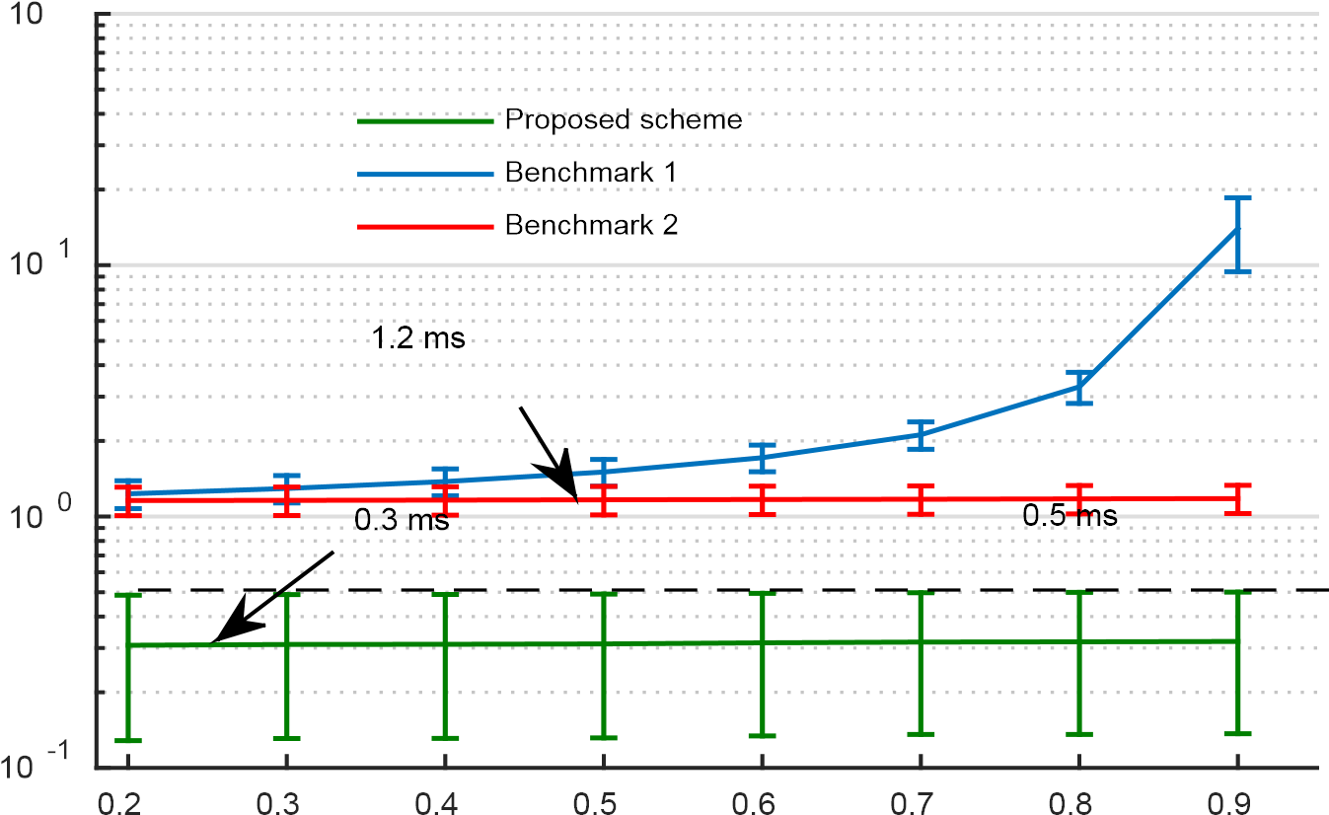

Latency(ms)

# Result

Comparing the efficiency of the upcoming 5G scheme with two benchmarks focused on traditional broadband backhaul networks based on PONs. It can be shown that, in terms of average E2E latency, the proposed device performs better.. (Bianchi, 2014)

# Code:

% Load data

load relatedsig.mat

figure

ax(1) = subplot(3,1,1);

plot((0:numel(T1)-1)/Fs1,T1,'k')

ylabel('Template 1')

grid on

ax(2) = subplot(3,1,2);

plot((0:numel(T2)-1)/Fs2,T2,'r')

ylabel('Template 2')

grid on

ax(3) = subplot(3,1,3);

plot((0:numel(S)-1)/Fs,S)

ylabel('Signal')

grid on

xlabel('Time (secs)')

linkaxes(ax(1:3),'x')

axis([0 1.61 -4 4])

[P1,Q1] = rat(Fs/Fs1); % Rational fraction approximation

[P2,Q2] = rat(Fs/Fs2); % Rational fraction approximation

T1 = resample(T1,P1,Q1); % Change sampling rate by rational factor

T2 = resample(T2,P2,Q2); % Change sampling rate by rational factor

[C1,lag1] = xcorr(T1,S);

[C2,lag2] = xcorr(T2,S);

figure

ax(1) = subplot(2,1,1);

plot(lag1/Fs,C1,'k')

ylabel('Amplitude')

grid on

title('Cross-correlation between Template 1 and Signal')

ax(2) = subplot(2,1,2);

plot(lag2/Fs,C2,'r')

ylabel('Amplitude')

grid on

title('Cross-correlation between Template 2 and Signal')

xlabel('Time(secs)')

axis(ax(1:2),[-1.5 1.5 -700 700 ])

figure,

ax(1) = subplot(3,1,1);

plot(s1)

ylabel('s1')

grid on

ax(2) = subplot(3,1,2);

plot(s2,'k')

ylabel('s2')

grid on

ax(3) = subplot(3,1,3);

plot(s3,'r')

ylabel('s3')

grid on

xlabel('Samples')

linkaxes(ax,'xy')

# Core Architecture

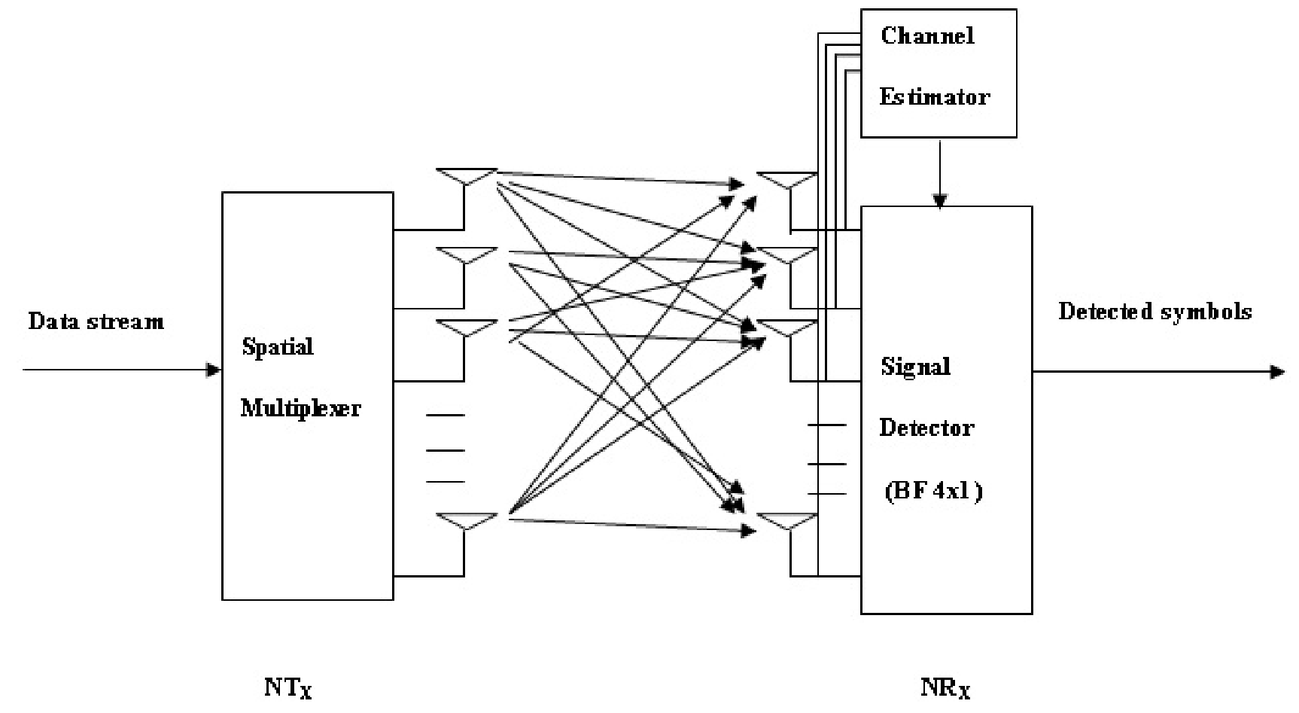

Cited. (Zhang,2014)

# References

C. A. Balanis, Antenna Theory and Design, John Wiley & Sons, New York, NY, USA, 1997.

R. Vescovo, ―Null synthesis by phase control for antenna arrays,‖ Electronics Letters, vol. 36, no. 3pp.198–199, 2000.

K. Güney and A. Akdagli, ―Null steering of linear antenna arrays using a modified tabu searchalgorithm,‖ Progress in Electromagnetics Research, vol. 33, pp. 167–182, 2001.

M. H. Er, ―Linear antenna array pattern synthesis with prescribed broad nulls,‖ IEEE Transactions on Antennas and Propagation, vol. 38, no. 9, pp. 1496–1498, 1990.

M. A. Panduro, D. H. Covarrubias, C. A. Brizuela, and F. R. Marante, ―A multi-objective approach in thelinear antenna array design,‖ AEU-International Journal of Electronics and Communications, vol. 59, no. 4, pp. 205–212, 2005.

D. Bianchi, S. Genovesi, and A. Monorchio, ―Design of linear arrays by employing randomly-overlappedsubarrays,‖ in Proceedings of the XXXIth URSI General Assembly and Scientific Symposium (URSI GASS'14), pp. 1–4, IEEE, Beijing, China, August 2014.

Z. Zhang, T. Li, F. Yuan, and L. Yin, ―Synthesis of linear antenna array using genetic algorithm to controlside lobe level,‖ in Computer Engineering and Networking, pp. 39–46, Springer, 2014.

B. Goswami and D. Mandal, ―A genetic algorithm for the level control of nulls and side lobes in linearantenna arrays,‖ Journal of King Saud University—Computer and Information Sciences, vol. 25, no. 2, pp.117–126, 2013.

V. Murino, A. Trucco, and C. S. Regazzoni, ―Synthesis of unequally spaced arrays by simulatedannealing,‖ IEEE Transactions on Signal Processing, vol. 44, no. 1, pp. 119–122, 1996.

Ancans, G. (2016). Spectrum Considerations for 5G Mobile Communication Systems. Retrieved 14 July 2020, from https://www.researchgate.net/publication/313486542_Spectrum_Considerations_for_5G_Mobile_Communication_Systems

Endeshaw Bogale, T. (2015). Massive MIMO and Millimeter Wave for 5G Wireless HetNet: Potentials and Challenges. Retrieved 14 July 2020, from <https://arxiv.org/pdf/1510.06359.pdf>

French, A. (2016). The Digital Revolution: Internet of Things, 5G, and. Retrieved 14 July 2020, from https://aisel.aisnet.org/cgi/viewcontent.cgi?article=3952&context=cais

Fulton, S. (2020). What is 5G? The business guide to next-generation wireless technology | ZDNet. Retrieved 14 July 2020, from https://www.zdnet.com/article/what-is-5g-the-business-guide-to-next-generation-wireless-technology/

Gavras, A. (2019). Validating 5G Technology Performance – TMV WG White Paper. Retrieved 14 July 2020, from <https://www.5g-vinni.eu/2019/06/06/validating-5g-technology-performance-tmv-wg-white-paper/>

Kritsonis, T., 2019. *Five Of The Biggest Challenges Facing 5G | Futurithmic By Nokia*. [online] Futurithmic. Available at: <https://www.futurithmic.com/2019/02/26/five-biggest-challenges-facing-5g/> [Accessed 14 July 2020].

Lin, C. (2017). Outage constrained robust hybrid coordinated beamforming for massive MIMO enabled heterogeneous cellular networks - IEEE Conference Publication. Retrieved 14 July 2020, from https://ieeexplore.ieee.org/document/7997438/

Marzetta, T., Yang, H., Larsson, E., & Ngo, H. (2016). *Fundamentals of Massive MIMO*. [Place of publication not identified]: Cambridge University Press.

Rawling, J. (2018). The Political and Ethical Problems of 5G Internet. Retrieved 14 July 2020, from <https://medium.com/the-politicalists/the-political-and-ethical-problems-of-5g-internet-7c5ab0ba9458>

Samimi, M. (2016). 3-D Millimeter-Wave Statistical Channel Model for 5G Wireless System Design - IEEE Journals & Magazine. Retrieved 14 July 2020, from https://ieeexplore.ieee.org/abstract/document/7501500

Saxena, N. (2017). Efficient IoT Gateway over 5G Wireless: A New Design with Prototype and Implementation Results - IEEE Journals & Magazine. Retrieved 14 July 2020, from <https://ieeexplore.ieee.org/abstract/document/7842418>

Yazıcı, V. (2014). A new control plane for 5G network architecture with a case study on unified handoff, mobility, and routing management - IEEE Journals & Magazine. Retrieved 14 July 2020, from https://ieeexplore.ieee.org/document/6957146/